
Name: Muhammad Zain
CU-4353-2023
BSSE-2023-C
Lab Task 2
- Create a Tuple with 10 Elements
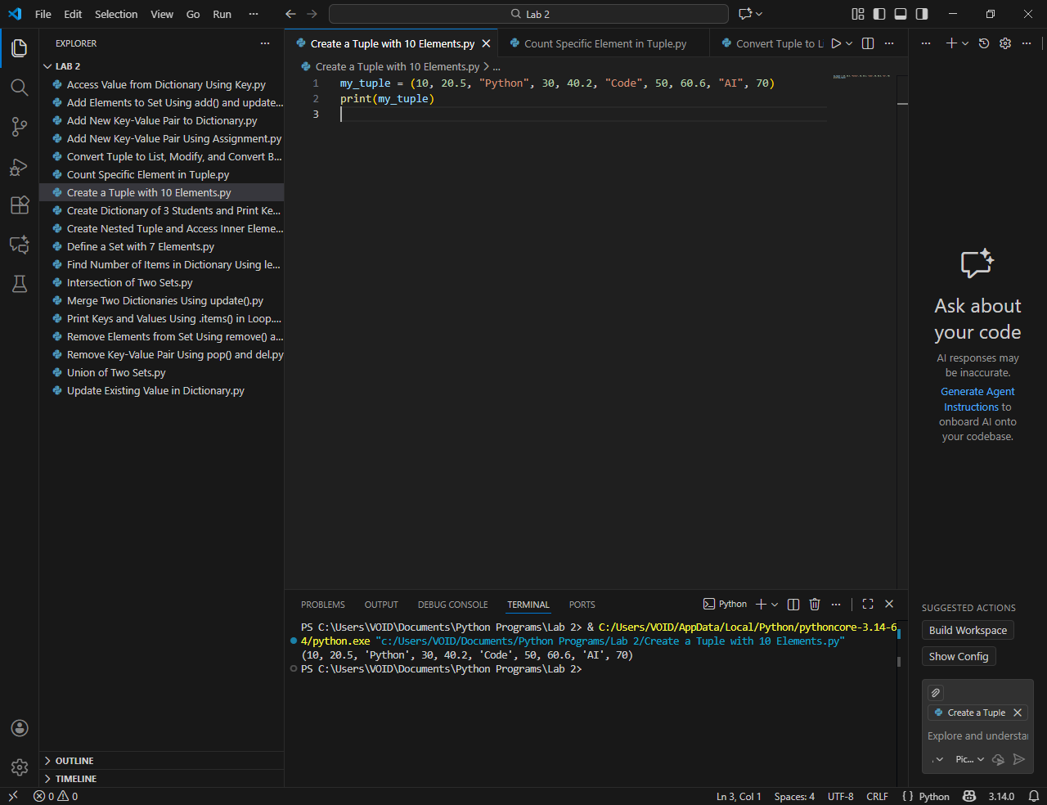
- Count Specific Element in Tuple
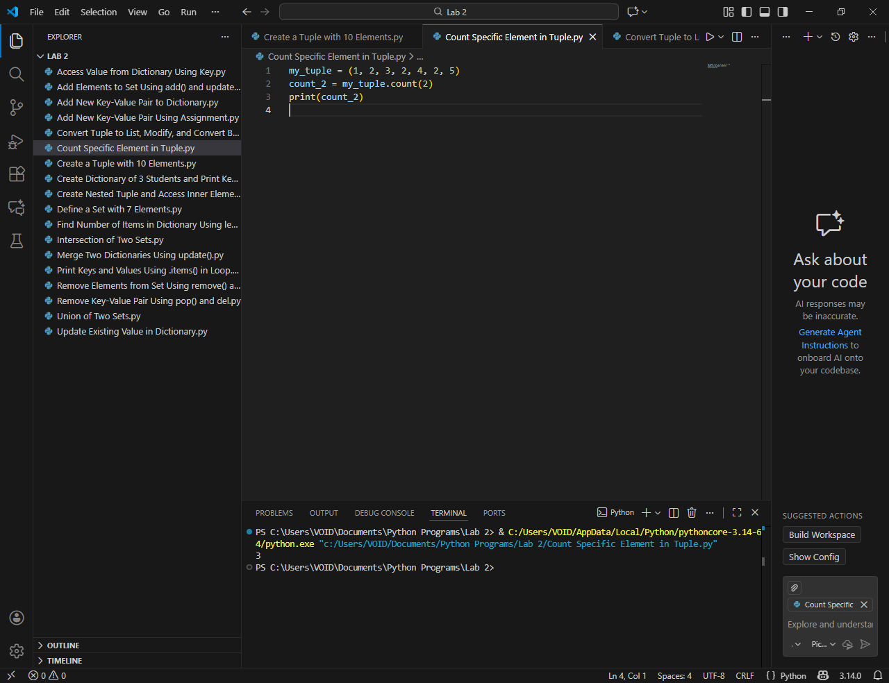
- Convert Tuple to List, Modify, and Convert Back
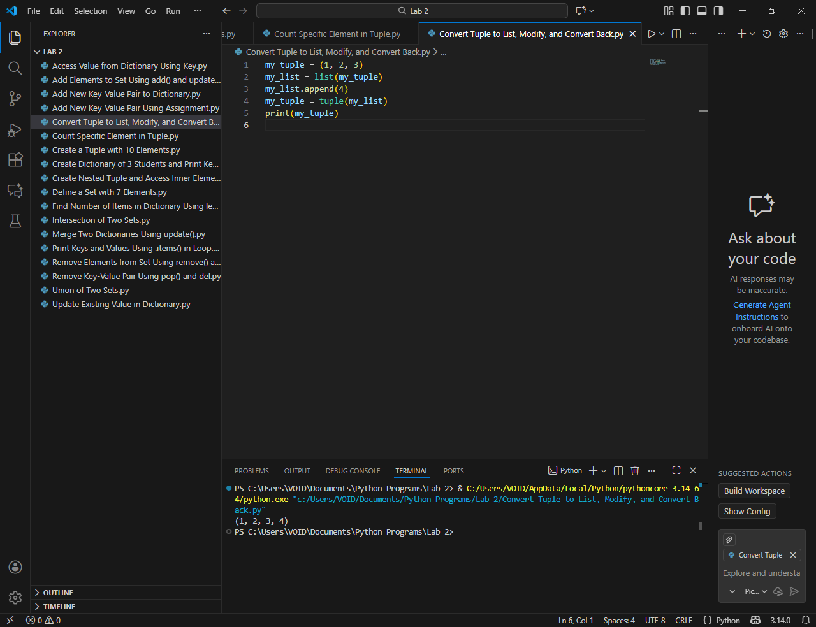
- Create Nested Tuple and Access Inner Elements
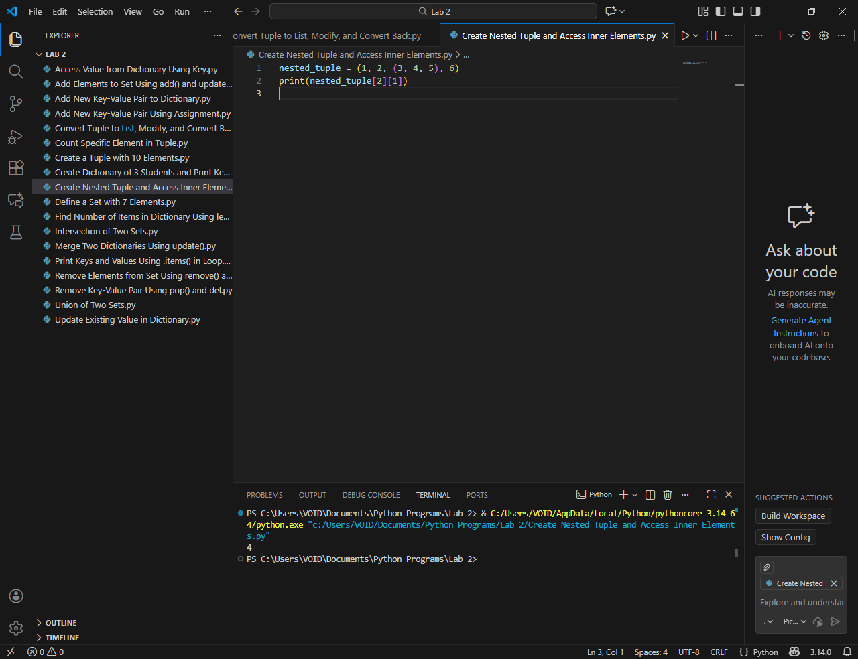
- Define a Set with 7 Elements
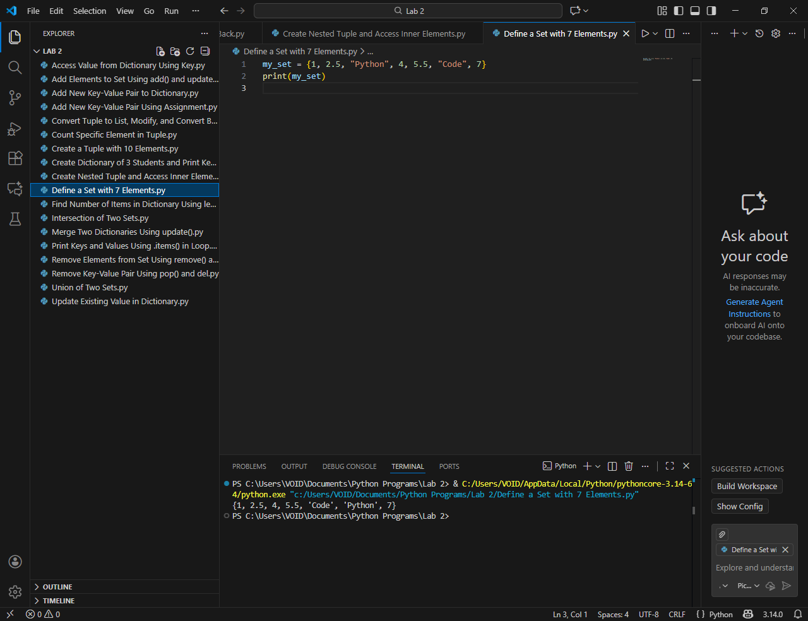
- Add Elements to Set Using add() and update()
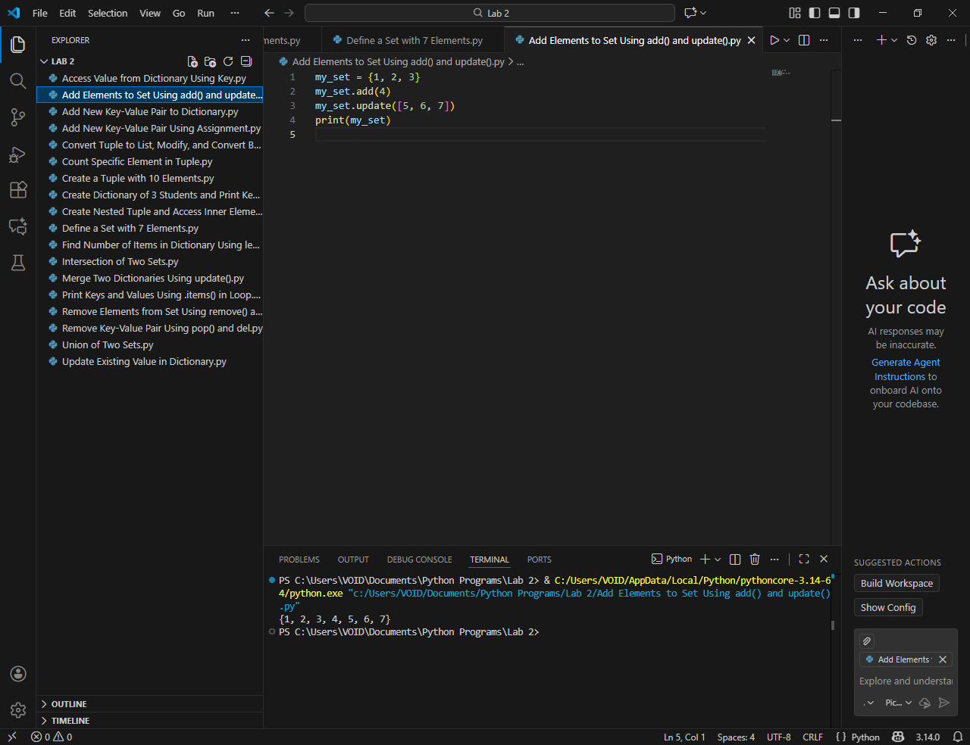
- Remove Elements from Set Using remove() and discard()
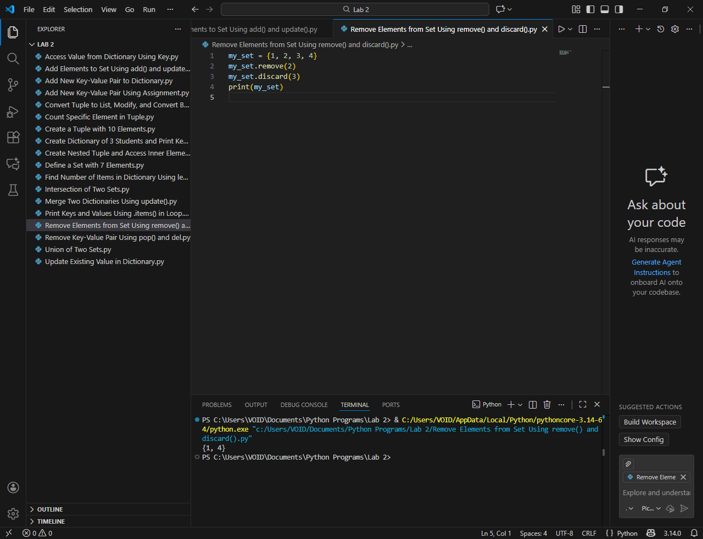
- Union of Two Sets
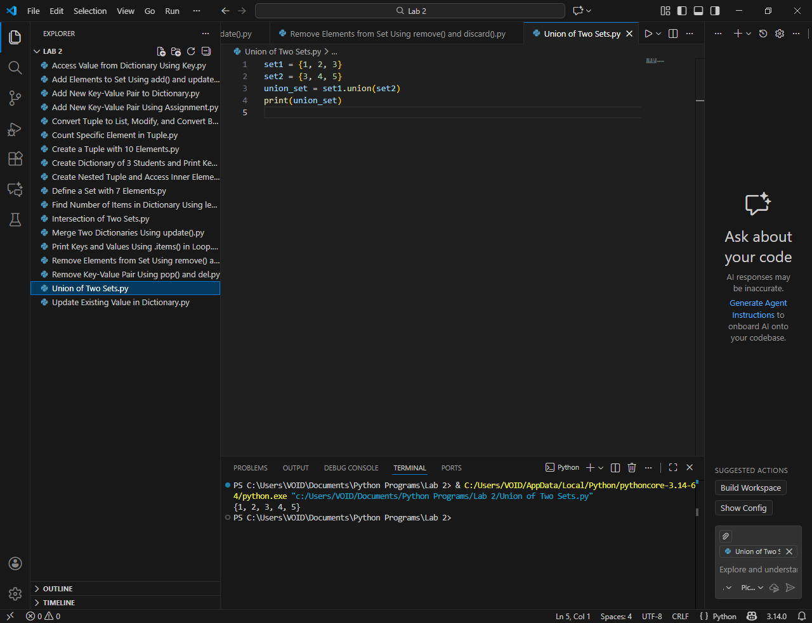
- Intersection of Two Sets
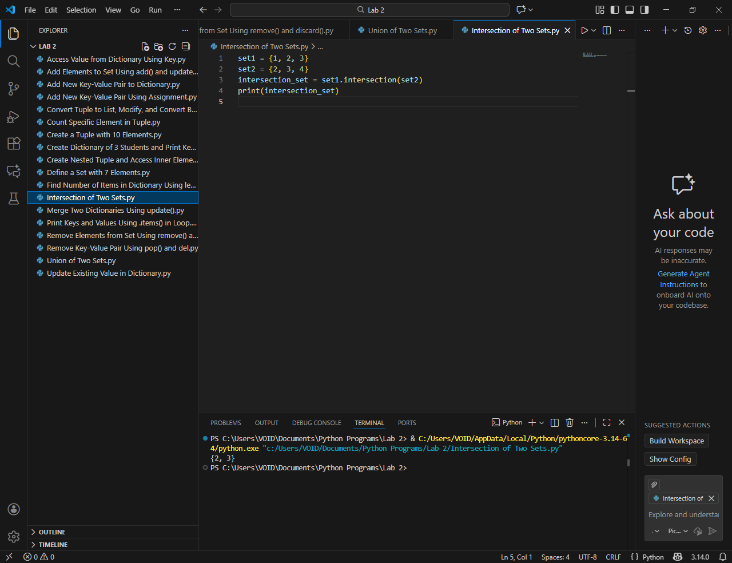
- Create Dictionary of 3 Students and Print Key-Value Pairs
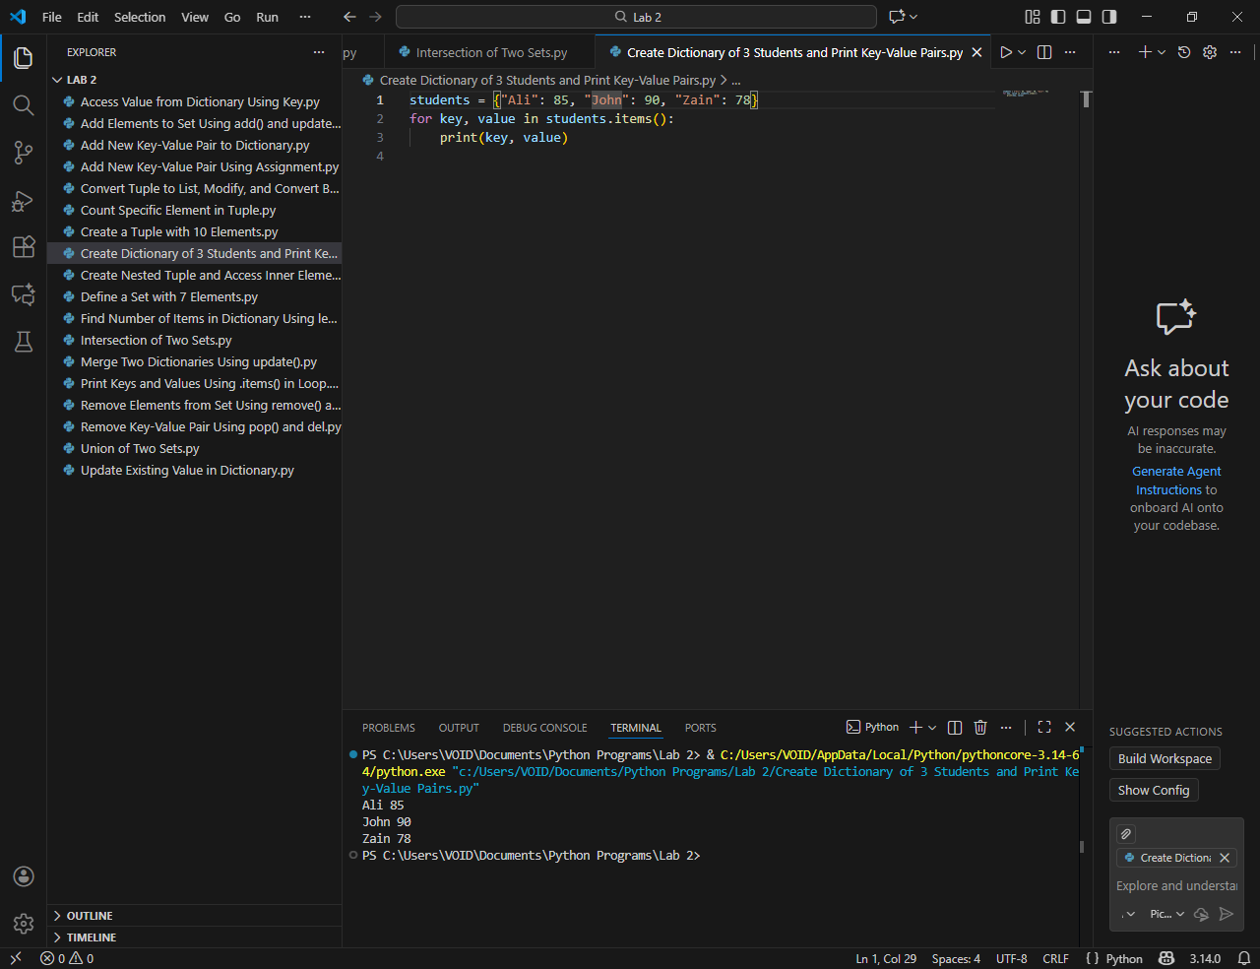
- Add New Key-Value Pair to Dictionary
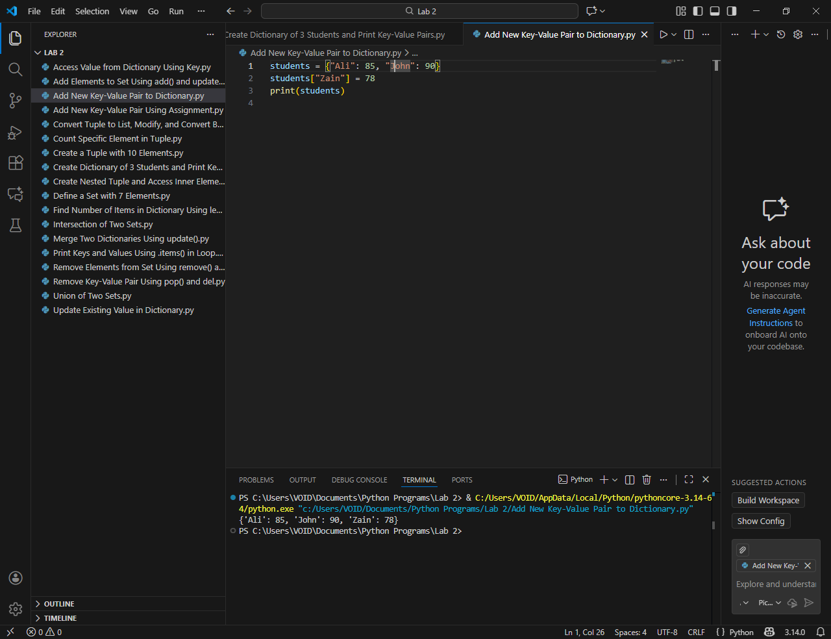
- Access Value from Dictionary Using Key
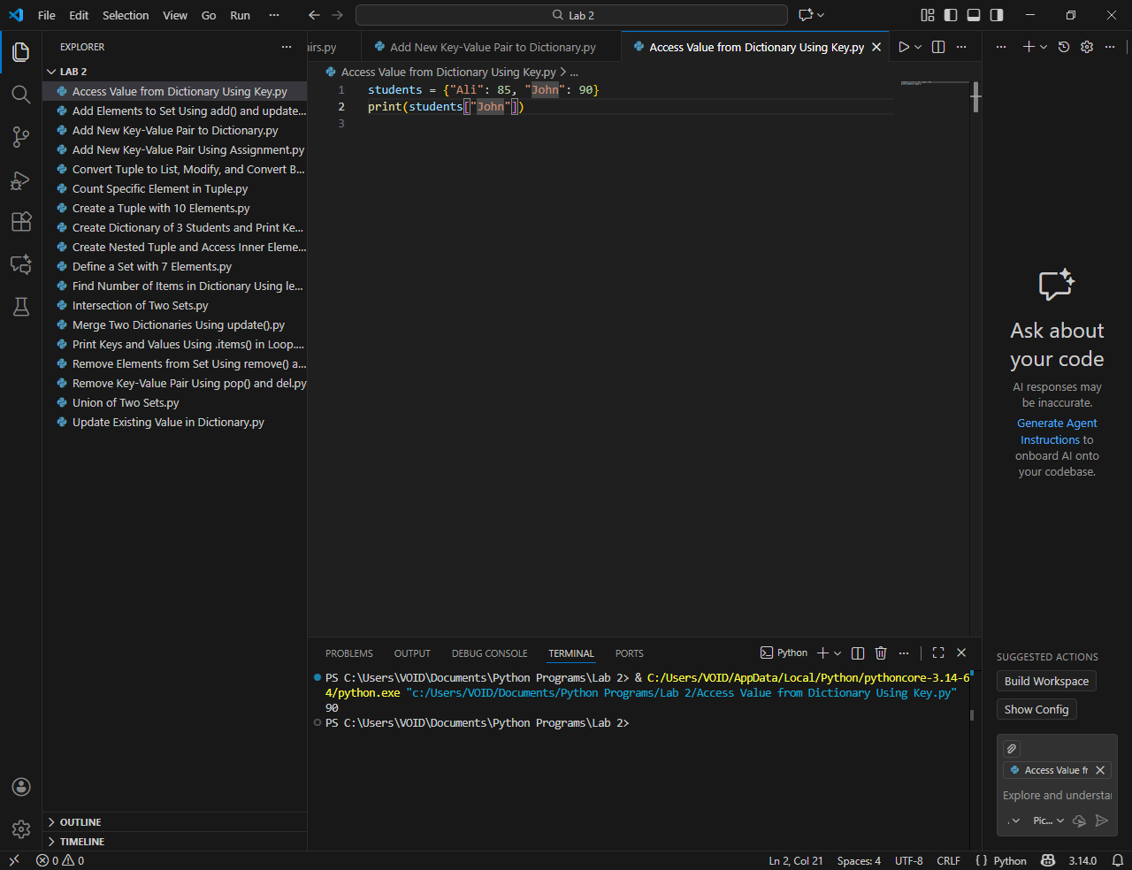
- Add New Key-Value Pair Using Assignment
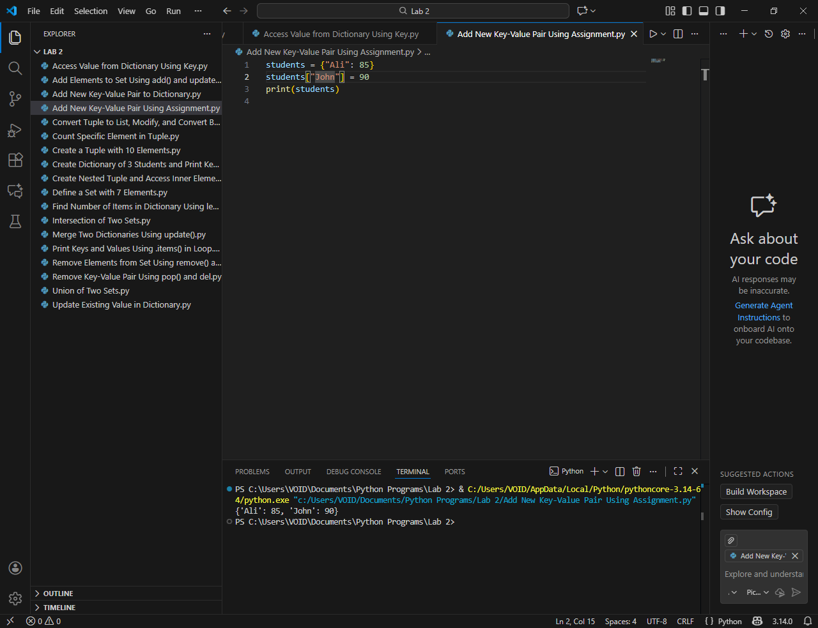
- Update Existing Value in Dictionary
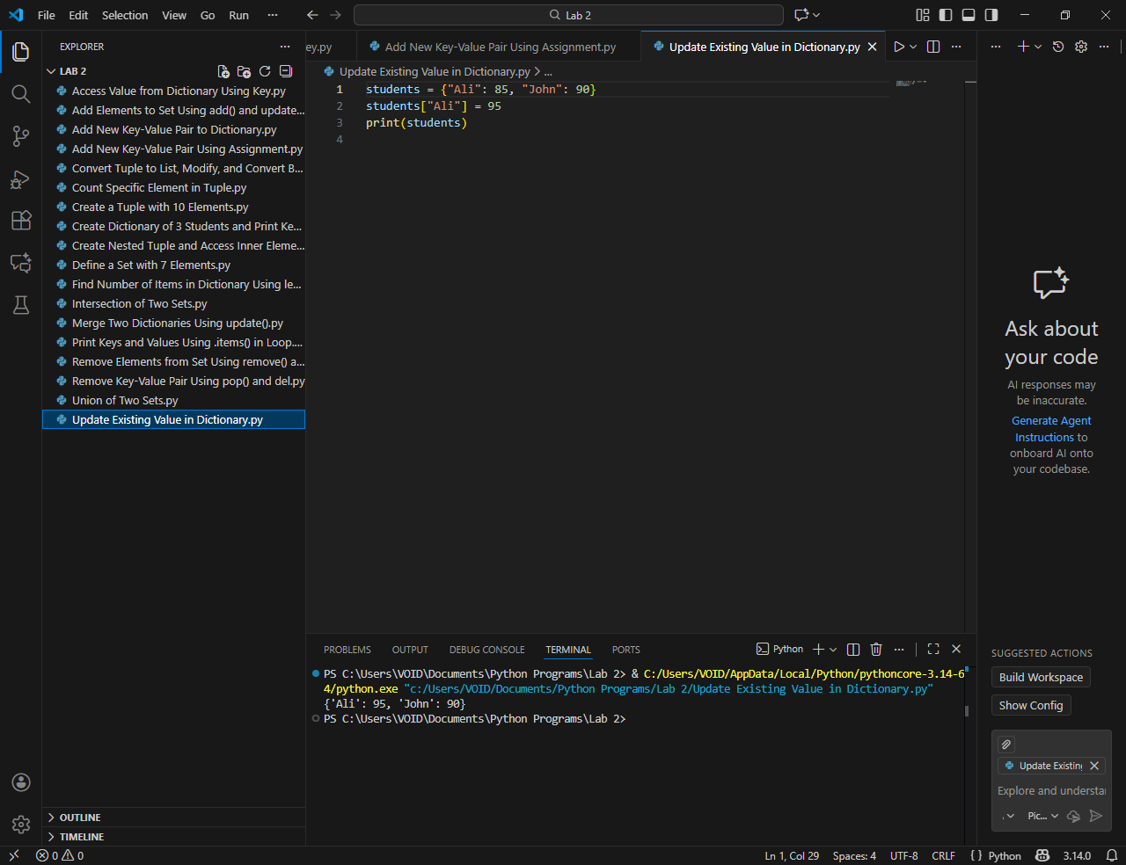
- Remove Key-Value Pair Using pop() and del
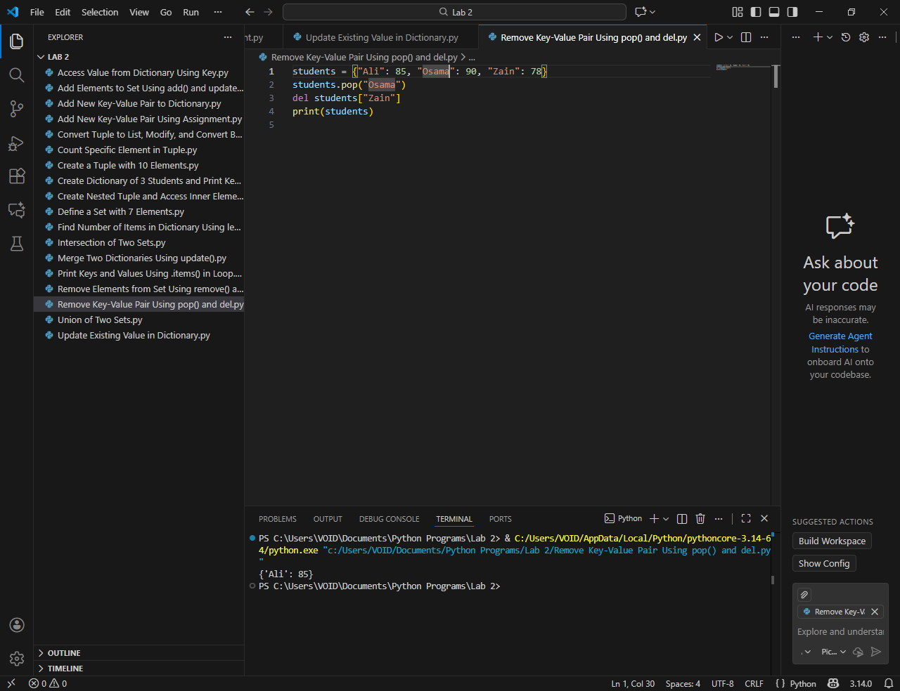
- Print Keys and Values Using .items() in Loop
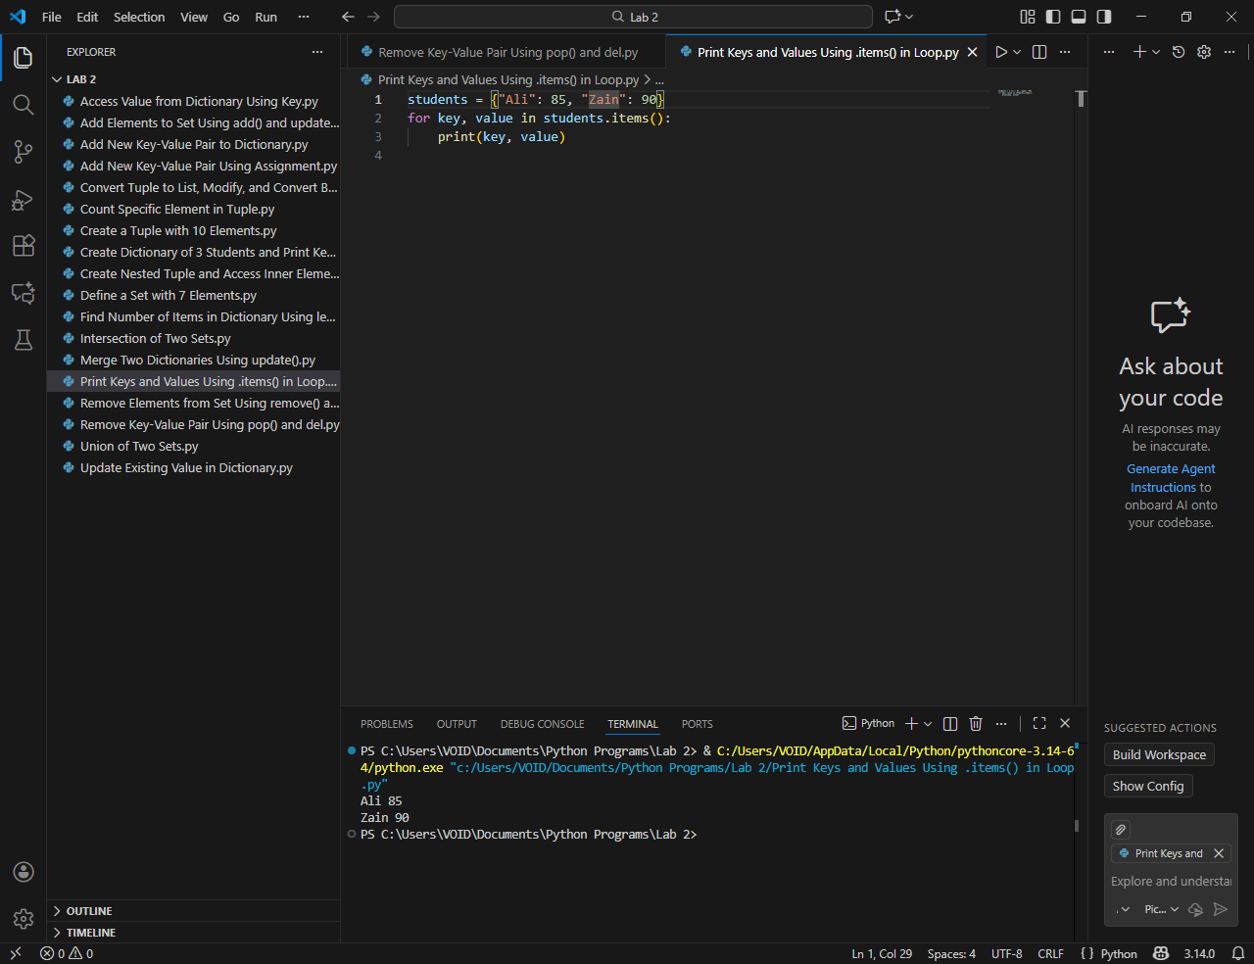
- Find Number of Items in Dictionary Using len()
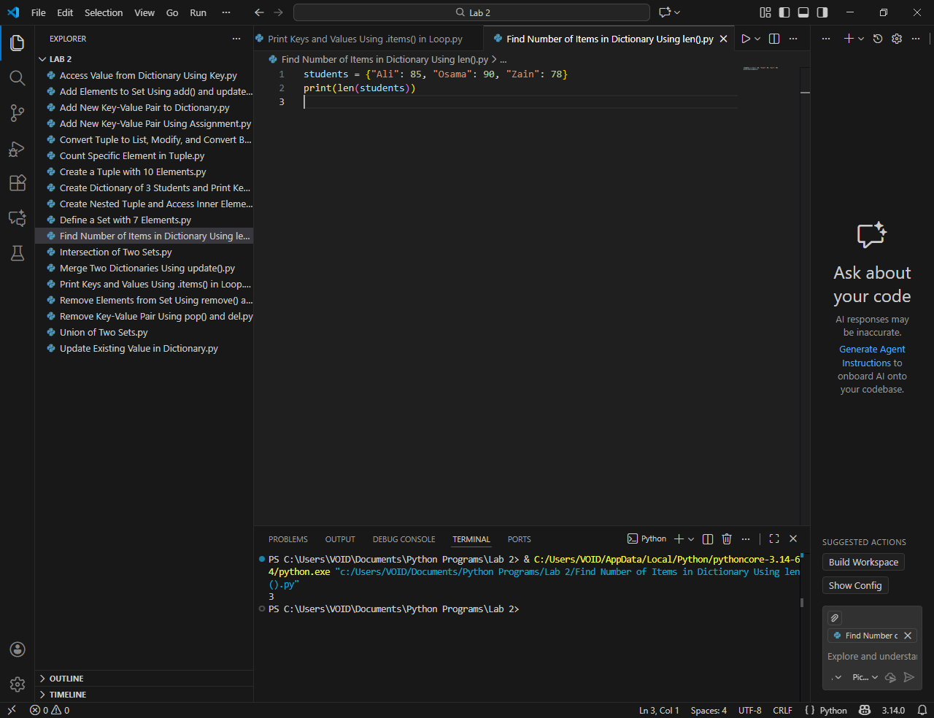
- Merge Two Dictionaries Using update()
